RESULTS SUMMARY

# Employing a Web Tool to collect public feedback on RCT PILs

Sad

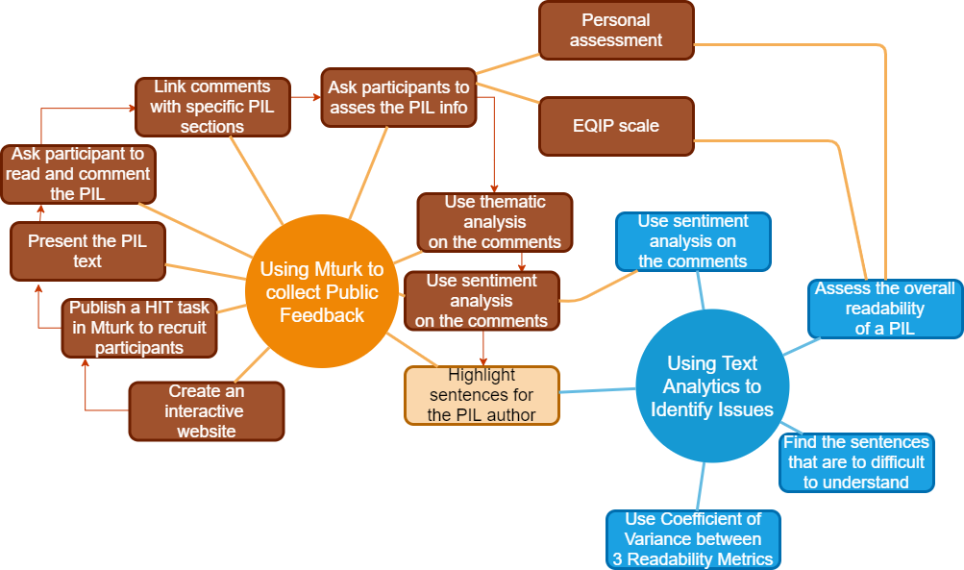

# Employing a Web Tool to objectively identify readability issues on PILs

Fd

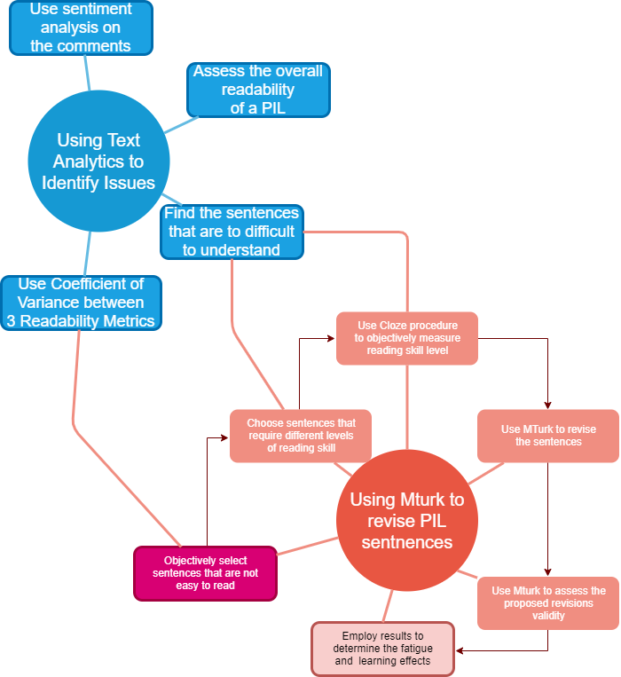

# Employing a Web Tool to revise low readability sentences from PILs

Dfd

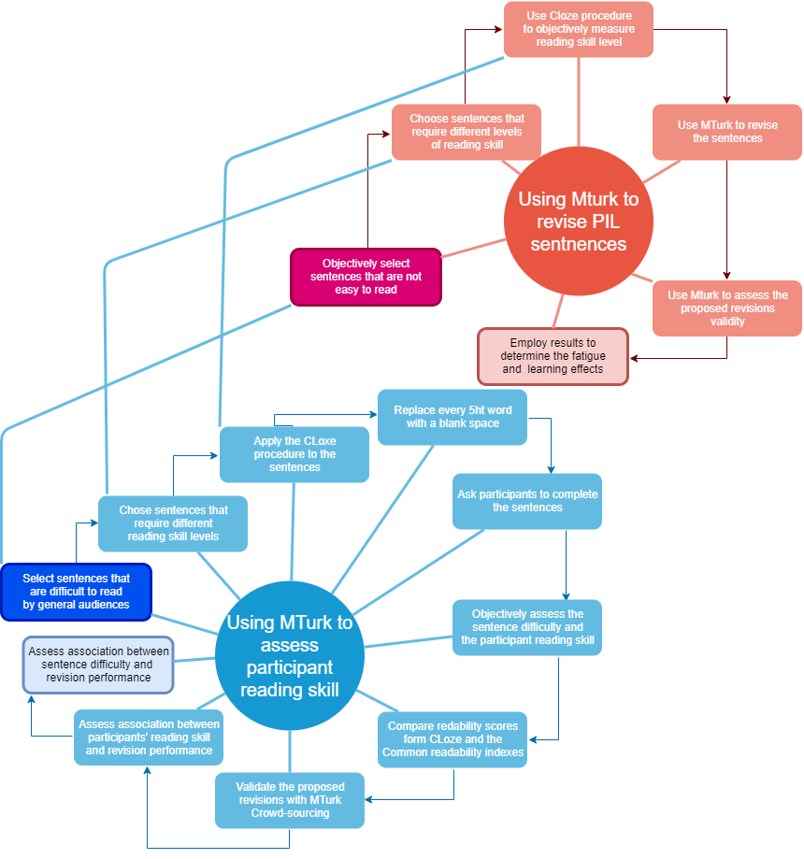

# Employing a Web Tool to assess association between sentence difficulty, reading skill level, learning and fatigue effects and participant performance.

Dss